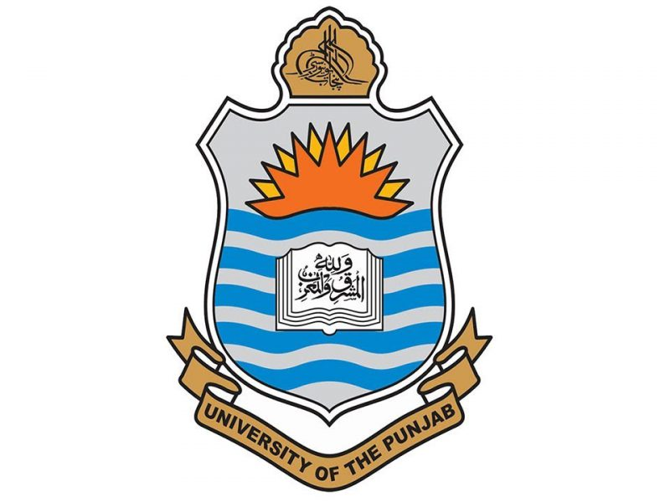

**FCIT**

**DEPARTMENT OF DATA SCIENCES**

**Communication and Presentation Skills**

**Research Report**

**COMMUNICATION THROUGH WORLD’S CUISINES**

**SUBMITTED TO: Ms Samreen Shahid**

**SUBMITTED BY: Muhammad Soban Anjum (BSDSF21A007),**

**Hamza Majeed (BSDSF21A016),**

**Muhammad Ahmad (BSDSF21A025),**

**Rabail (BSDSF21A032)**

**SUBMISSION DATE: 16 November 2022**

**Letter of Transmittal:**

November 16,2022

Ms Samreen Shahid  
Communication and Presentation Skills Ma’am

PUCIT, New Campus,   
West Canal Bank,  
Near SUPARCO

LAHORE

54770

**SUBJECT: Submission of semester report on “Communication through World’s Cuisines.”**

Dear Ms Samreen,

This is to inform you that we have completed the research report that you have assigned us for the course “Communication Skills”. We chose to write our research report on “Communication Through World’s Cuisine” We have discussed different cuisines of various regions of the world including Far eastern, middle East, Subcontinental and European.

Our team has done a lot of hard work and each and every one of us has made efforts to make this research a reliable one. All of us made this report with our collective efforts. We have tried our level best to abide by all rules and guidelines. All of the data used in this report is from authentic and credible resources with credits mention.

Yours sincerely,

Muhammad Soban Anjum

Student

[bsdsf21a007@pucit.edu.pk](mailto:bsdsf21a007@pucit.edu.pk)

+92 303 5151021